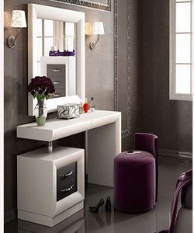

Durian glossy dressing table

$107.39

Availability: In stock

**Description:**

Durian dressing table with 2 Drawer Vanity with Mirror is perfect for providing storage and space in the bathroom, bedroom or dressing area. The spacious top represents a good open storage. Two storage drawers provide ample hidden storage space for small items. The finish and contemporary design are adaptable for any decor style. It is perfect to prepare yourself for a day of work or important date at night.